CONTENTS

**WORKSHOP ON ARDUINO**

**INTRODUCTION AND OBJECTIVE**

Arduino is a prototype platform (open-source) based on an easy-to-use hardware and software. It consists of a circuit board, which can be programed (referred to as a microcontroller) and a ready-made software called Arduino IDE (Integrated Development Environment), which is used to write and upload the computer code to the physical board. The objective of this workshop was to introduce the students to Arduino, which is the first step towards learning embedded systems. The workshop aimed at making students capable of tackling problems that they might face while working with Arduino boards using software and hardware techniques. In addition, this would help them immensely in their minor projects.

**EVENT DETAILS**

**Conducted on (Date):** January 18th – January 21st, 2018[Thursday-Sunday]

**Number of Participants:** 15 teams and 6 individual contestants.

**Event Coordinators:** Shantanu Mangalam (3rd year, ECE)

Shivam Saini (3rd year, ECE)

**Topics Covered:**

* Arduino Introduction
* Difference between microprocessor and microcontroller.
* Arduino pins (Analog and digital pins)
* Built in ICs
* Voltage and current capacity of Arduino and operating frequency resistors
* Color coding
* LEDs
* Common anode and cathode configuration of LED
* Codes for Glowing and blinking LED
* Pull up and pull down configuration of push button
* Serial terminal
* Codes for push button
* PWM in LED
* Multicolor LED
* Concept of Duty cycle
* Clock and counter
* Pseudo analog signals
* ADCs and resolutions
* Potentiometer
* Buzzer and it's code
* Codes for LEDs and pot
* Communication protocols(UART , I2C )
* Various sensors(LDR, IR, ultrasonic )
* And their interfacing with Arduino
* Codes on these sensors
* Display of project(obstacle avoider robot)
* Circuit for Traffic light
* Automatic street light using LDR

**Software Used:** Arduino IDE 1.8.5

**Equipment used per team:**

* Arduino UNO
* Resistors(220, 10, 1000)
* LED(B, G, R)
* 3 in 1 LED
* LDR
* Speaker
* 7 Segment
* Pot(10k)
* Ultrasonic sensor
* IR sensor
* Photodiode
* Jumper(M-M)
* Bread-board
* Push-button(small)
* Battery
* Batter Cap

**SOME SNAPS FROM THE EVENT**

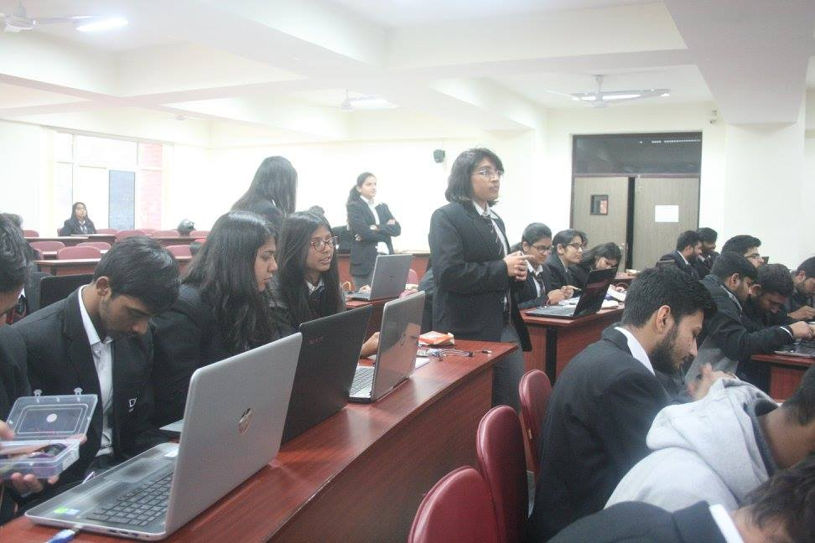 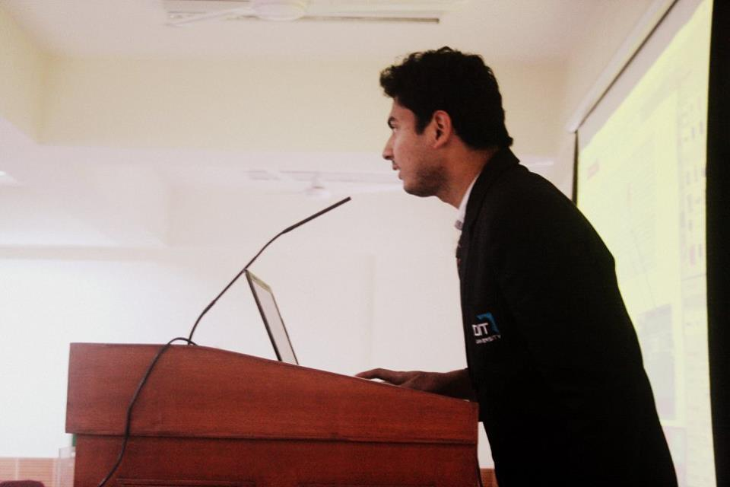

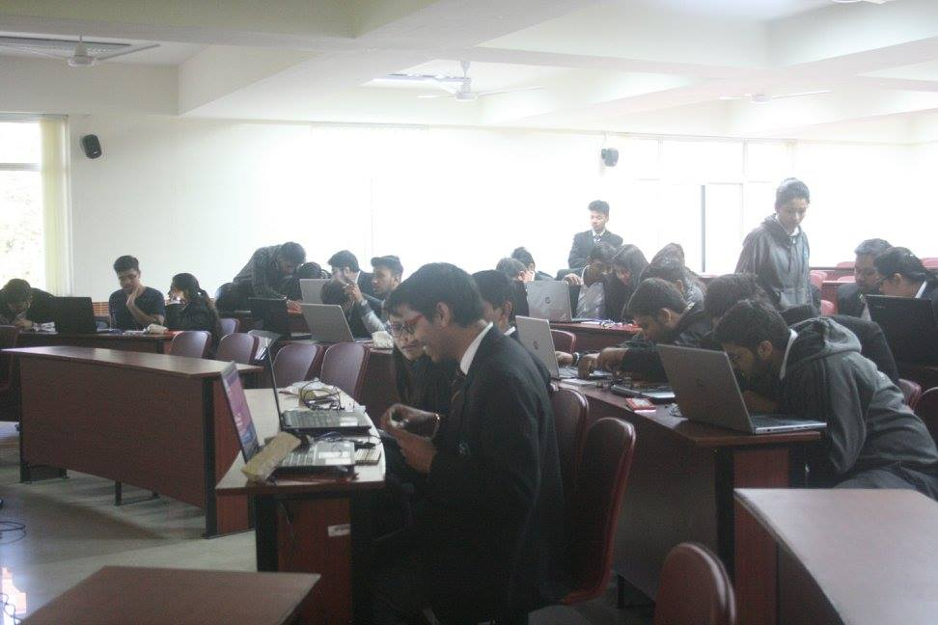 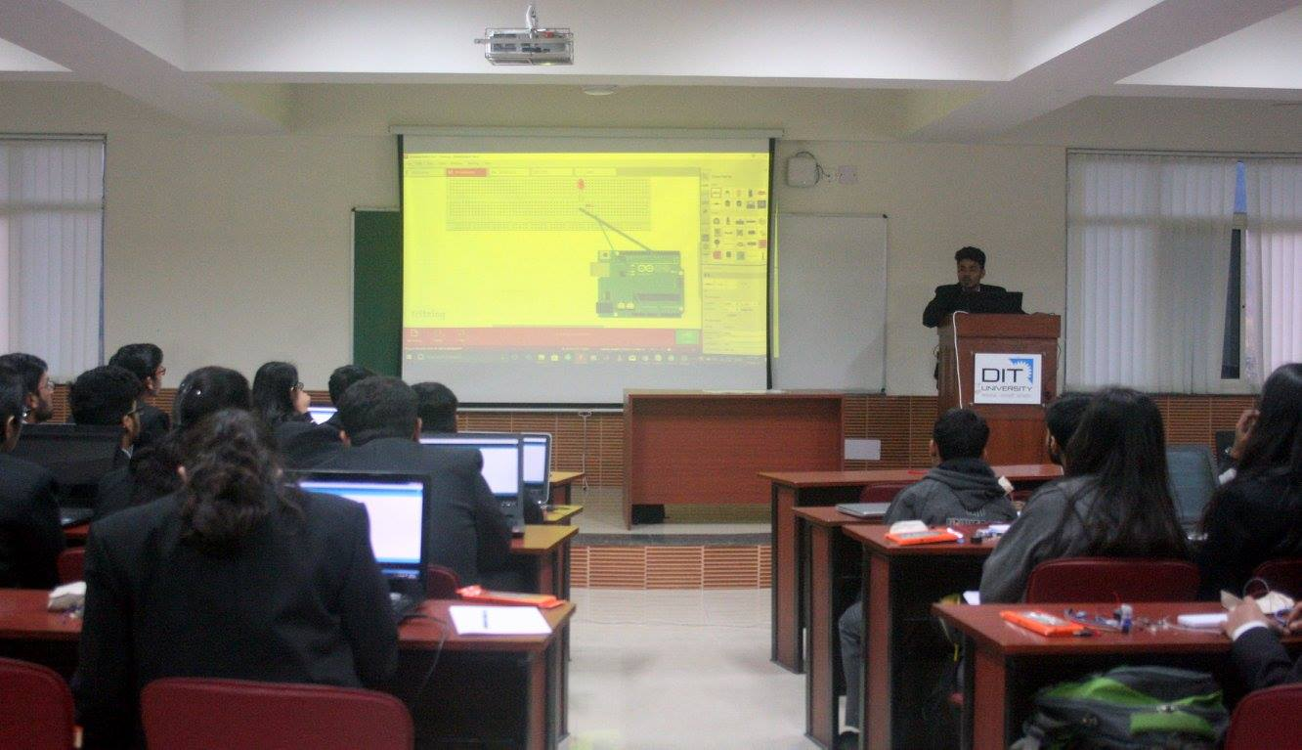

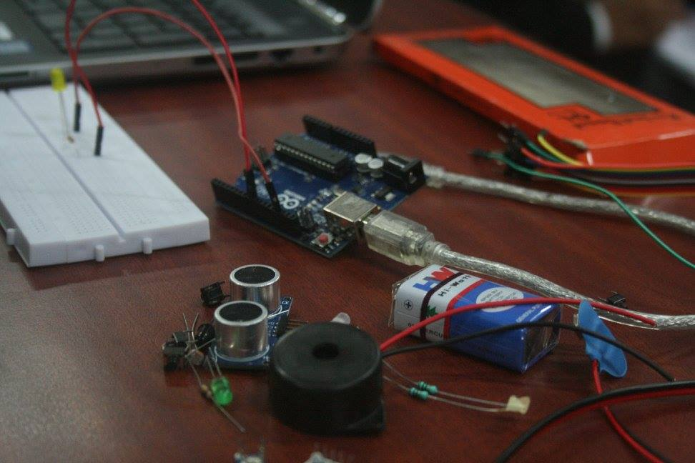 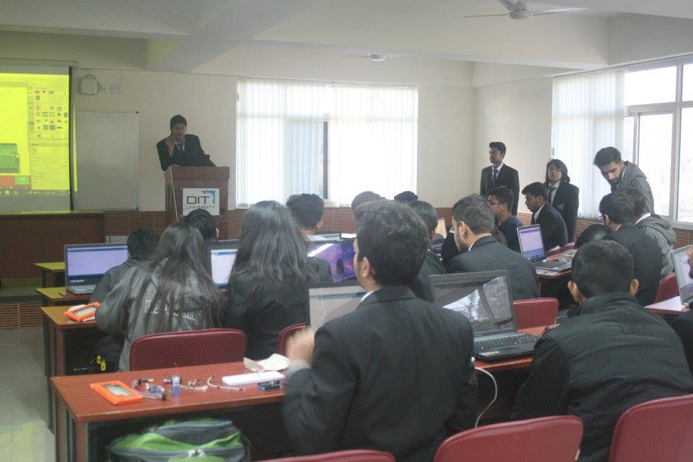

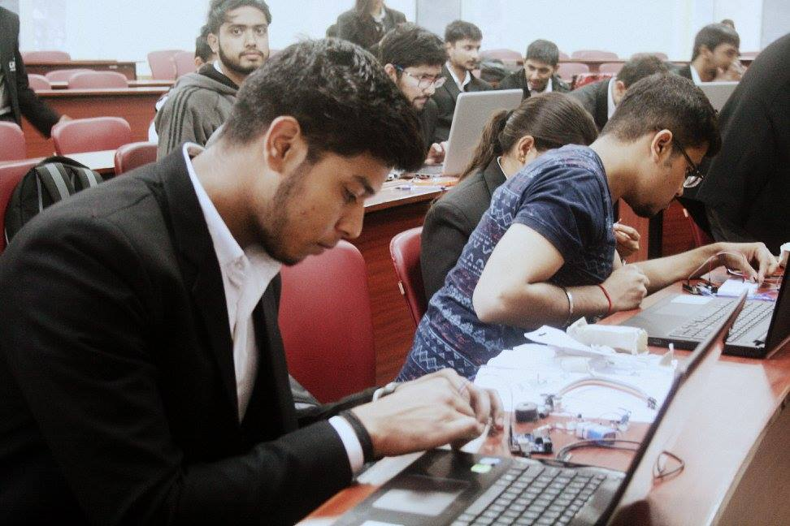 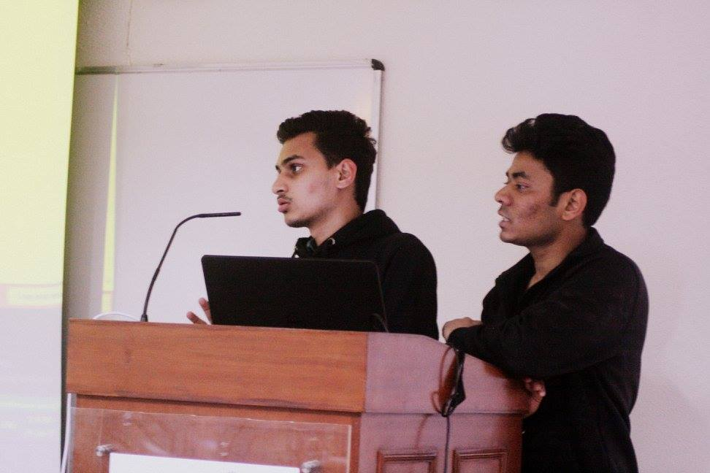

**WORKSHOP ON SPRITE ANIMATION**

**INTRODUCTION AND OBJECTIVE**

Sprite Animation is a technique for creating animations and 2D games. This can be made using spritesheet, JavaScript, and HTML5 canvas elements. The workshop aimed at making students capable of understanding simple games algorithms using sprites and to make a simple games using the technique. At the end of the workshop the students made their own canvas games.

**EVENT DETAILS**

**Conducted on (Date):** February 1st & 2nd 2018[Thursday-Friday]

**Timing:** 04:00pm-06:00pm

**Event Coordinators:** Shivangi Gupta (1st year, CSE)

Elisha Ojha (3rd year, IT)

**Topics Covered:**

* Basics of HTML and HTML5
* Basics of JavaScript
* Introduction to spritesheets and sprite animation
* Canvas (HTML5 Element)
* User control in animation through buttons
* 2D game making using canvas and sprite

**Software Used:** Notepad++

Web Browser (any)

**SOME SNAPS FROM THE EVENT**

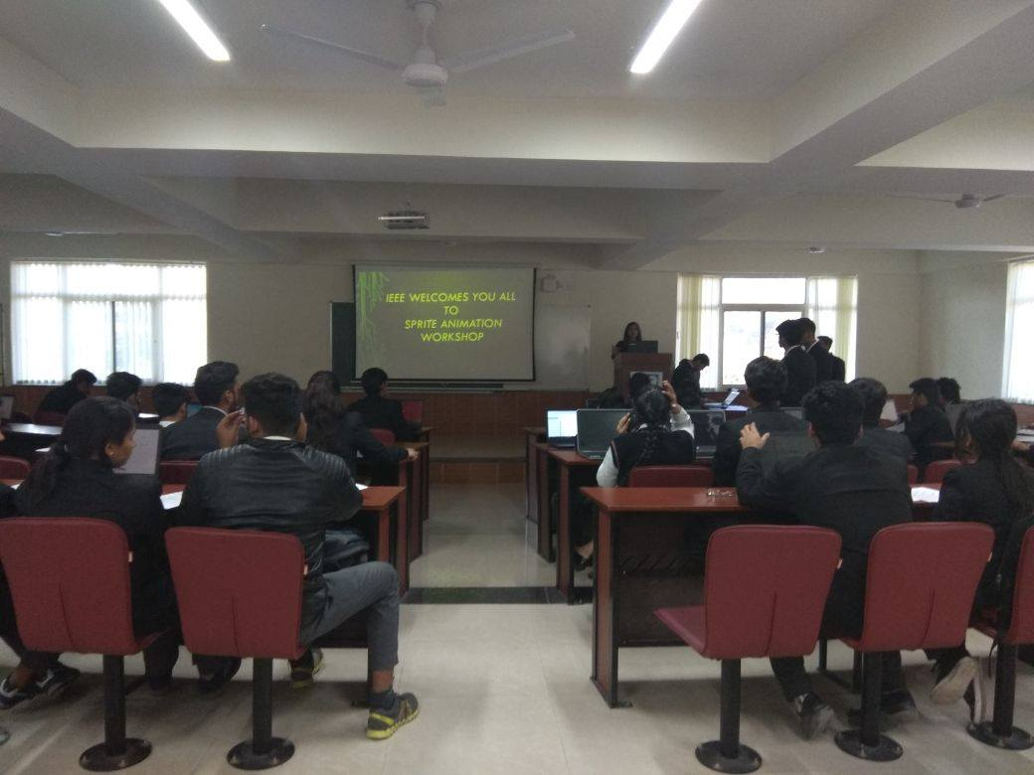 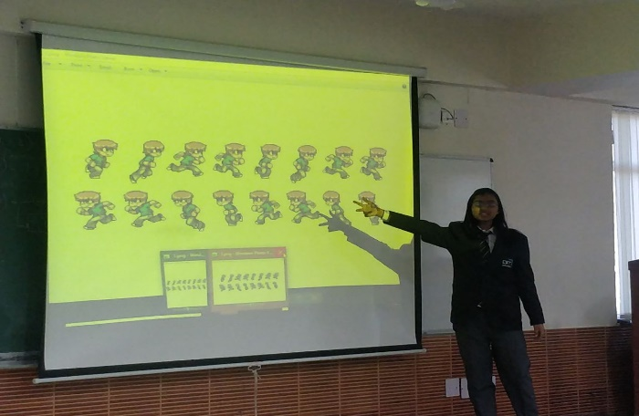

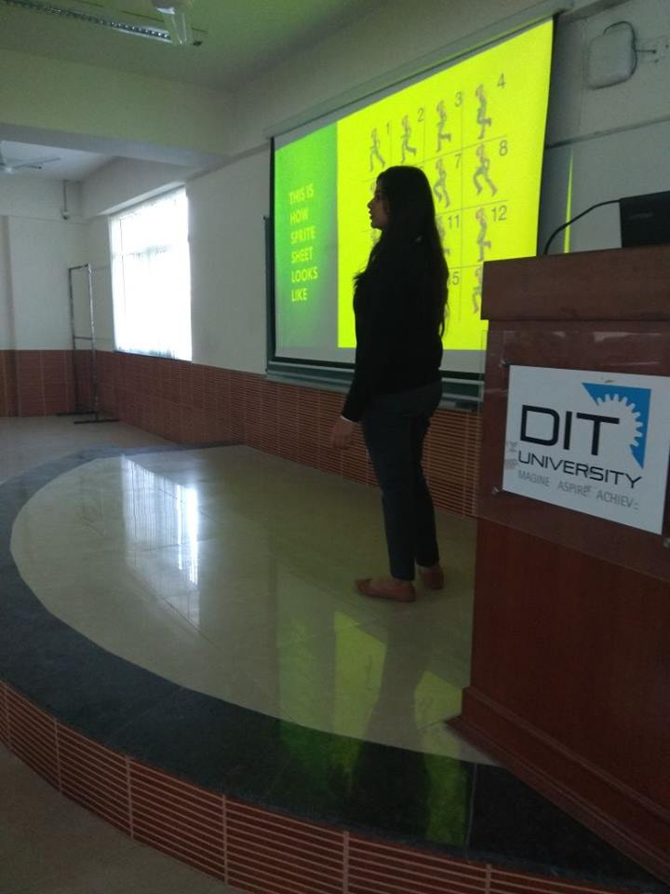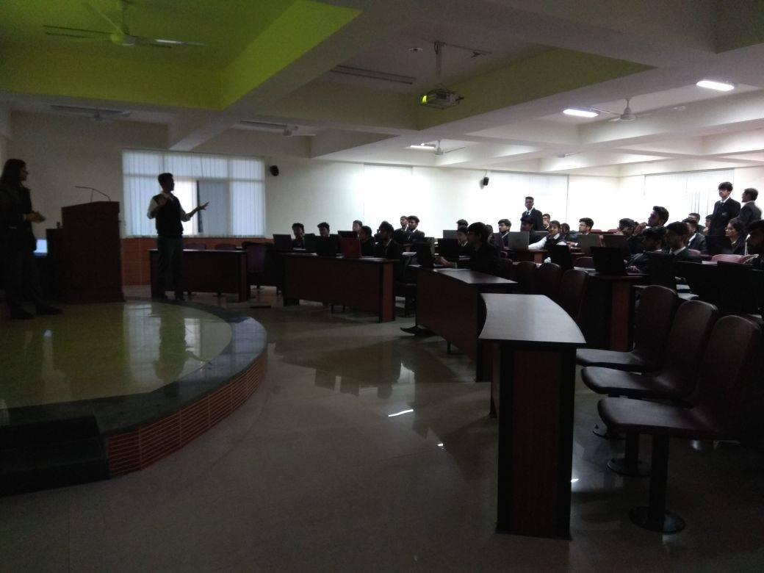

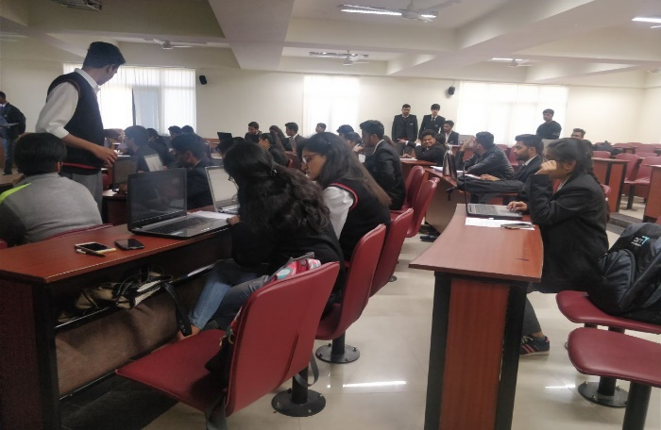 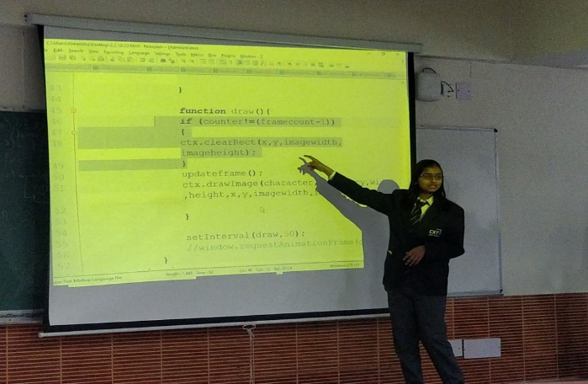

**SHERLOCKED**

Sherlocked was a detective competition in which teams of 3 **Proved their detective and reasoning skills in a nerve wrecking challenge to find and decipher clues which lead them to their final destination. The challenge was organized in Youthopia the technical fest of DIT University. With the right tools and the right knowledge Sherlock Holmes, in any era, is a frightfully modern man. Participants checked that ability in themselves in an innovative and technical way.**

**The event was conducted in 2 rounds, the first was a treasure hunt where various clues were distributed all over the college campus, and the second round was a laboratory which lead the participants to the final destination using various hints containing Morse code, coding skills and virtual reality.**

**The winners was awarded with attractive cash prizes.**

No. of participants: 110

**Date: 1-3 November’17**

**ROBO SOCCER**

Football is the beautiful game that is a pleasure to watch and a satisfaction to play as it brings rejoice around the world. Robots are a thing of technical excellence that perform all the tasks of man, hence reducing the efforts required by him. The task was to build three wired/wireless remote-controlled robots which can assist the ball to the opponent’s area and thereby, try to score a goal. Basic football rules, the team who scored the most goals, won. **The game was organized in Youthopia the technical fest of DIT University. Volunteers from 3rd year ECE departments were assigned as mentors for each team who assisted them to make better robots.**

**The winners was awarded with attractive cash prizes.**

No. of participants: 24

**Date: 1st November’17**

**MAKERS’ CHALLENGE**

A maker space culture, one that emphasizes creation over memorization, open source sharing over soiled knowledge, and process over product, gives new ways for students to explore concepts and show what they know. The execution of this challenge was planned out in the following manner - Virtual money was allotted to the participants, by the use of a mobile app developed by the coordinators to keep count of purchases of the components that the students selected for building their projects. Scanning the QR code would deduct the given amount of the component from the participant's total virtual money. The participants were given a time limit of 5 hours to build something productive from their selected components. No use of heavy machinery or high voltage devices was involved in the project making. Projects were judged and positions were awarded to the top 2 projects. **The game was organized in Youthopia the technical fest of DIT University.**

**The winners was awarded with attractive cash prizes.**

No. of participants: 20

**Date: 3rd November’17**

**MAZE SOLVER**

**IEEE, DITU organized line maze solver event where in teams had to build an autonomous robot which follows a black line and keep track of directions while going through the maze. The bot had to analyze the path in dry run and had to go through the maze from the starting point to the ending point in minimum possible time. The event was held in 2 rounds. The game was organized in Youthopia the technical fest of DIT University. Volunteers from 3rd year ECE departments were assigned as mentors for each team who assisted them to make better robots.**

**The winners was awarded with attractive cash prizes.**

No. of participants: 20

**Date: 3rd November’17**

**Content for ACHIEVEMENT:**

## **Second and third position in State level India skills competition**

Ministry of Skill Development and Entrepreneurship (MSDE) & National Skill Development Corporation (NSDC) launched India’s first National Skills Competition- IndiaSkills, a biennial competition.The competion was divided into various levels and on 16th April,2018 was the state level competition in DIT, university. Our two teams participated and secured second and third positions and also qualified for national training and regional competitions.

The first round was a line follower and the second one was a maze solver our teams made an automatic robot using Arduino, IR sensor array, motor, motor driver. The codes were written in embedded C for the Arduino board considering the various curves, and obstacles that the path may have. The robot was not only capable of sensing it’s path but also correcting itself if diverted.

Second position : [Rao Dheeraj](https://www.facebook.com/raodheeraj129?fref=mentions) (ece third year) and [Himanshu Kotnala](https://www.facebook.com/himanshu.kotnala99?fref=mentions) (cs first year)

Third position :[Neelesh Raina](https://www.facebook.com/neelesh.raina.58?fref=mentions) (ece first year)and [Nishchay Singh Muktawat](https://www.facebook.com/smartnishchay?fref=mentions) (cs first year).

#### ADD pictures from facebook